IRF23/1001

Gateway determination report – PP-2023-404
Reclassification of land at 2 Rose Street & Kanbyugal Reserve
May 23

Published by NSW Department of Planning and Environment
dpie.nsw.gov.au
Title: Gateway determination report – PP-2023-404
Subtitle: Reclassification of land at 2 Rose Street & Kanbyugal Reserve
© State of New South Wales through Department of Planning and Environment 2023. You may copy, distribute, display, download and otherwise freely deal with this publication for any purpose, provided that you attribute the Department of Planning and Environment as the owner. However, you must obtain permission if you wish to charge others for access to the publication (other than at cost); include the publication in advertising or a product for sale; modify the publication; or republish the publication on a website. You may freely link to the publication on a departmental website.
Disclaimer: The information contained in this publication is based on knowledge and understanding at the time of writing (May 23) and may not be accurate, current or complete. The State of New South Wales (including the NSW Department of Planning and Environment), the author and the publisher take no responsibility, and will accept no liability, for the accuracy, currency, reliability or correctness of any information included in the document (including material provided by third parties). Readers should make their own inquiries and rely on their own advice when making decisions related to material contained in this publication.

Acknowledgment of Country
The Department of Planning and Environment acknowledges the Traditional Owners and Custodians of the land on which we live and work and pays respect to Elders past, present and future.

Contents
1 Planning proposal 1
1.1 Overview 1
1.2 Objectives of planning proposal 1
1.3 Explanation of provisions 2
1.4 Site description and surrounding area 4
1.5 Mapping 6
2 Need for the planning proposal 9
3 Strategic assessment 10
3.1 Regional and District plans 10
3.1.1 Greater Sydney Region Plan 10
3.1.2 Western City District Plan 10
3.1.3 Glenfield to Macarthur Urban Renewal Corridor Strategy and Campbelltown Precinct Plan 11
3.2 Local plans 11
3.3 Local planning panel (LPP) recommendation 12
3.4 Section 9.1 Ministerial Directions 12
3.5 State environmental planning policies (SEPPs) 16
4 Site-specific assessment 18
4.1 Environmental 18
4.1.1 Flooding 18
4.2 Social and economic 19
4.3 Infrastructure 19
5 Consultation 19
5.1 Community 19
5.2 Agencies 19
6 Timeframe 19
7 Local plan-making authority 20
8 Assessment summary 20
9 Recommendation 20

Table 1 Reports and plans supporting the proposal
Relevant reports and plans
Title Searches (10 August 2022)
Responses to PN 16-001
Proposed Reclassification Map
Proposed Land Zoning Map
Legal Advice to Council (17 December 2022)
Proposed Height of Building Map
Proposed Lot Size Map

Planning proposal

Overview
Table 2 Planning proposal details
LGA | Campbelltown
PPA | City of Campbelltown Council
NAME | Reclassification of Land at 2 Rose Street & Kanbyugal Reserve (0 homes, 0 jobs)
NUMBER | PP-2023-404
LEP TO BE AMENDED | Campbelltown Local Environmental Plan 2015
ADDRESS | 2 Rose Street, Campbelltown & Kanbyugal Reserve, Campbelltown
DESCRIPTION | Lot 21 DP 572308 and part of Lot 22 DP 572308
RECEIVED | 23/02/2023
FILE NO. | IRF23/1001
POLITICAL DONATIONS | There are no donations or gifts to disclose and a political donation disclosure is not required
LOBBYIST CODE OF CONDUCT | There have been no meetings or communications with registered lobbyists with respect to this proposal

Objectives of planning proposal
The planning proposal contains objectives and intended outcomes that adequately explain the intent of the proposal.
The objectives of the planning proposal are:
- to reclassify the part of Kanbyugal Reserve which contains the existing animal care facility to operational land,
- to rezone the proposed operational land from RE1 Public Recreation to E4 General Industrial to be consistent with the existing operational land, and
- to apply maximum height of building and minimum lot size to the proposed operational land to be consistent adjoining industrial zoned land.
The objectives of this planning proposal describe changes to ‘boundary alignment’. To avoid any potential confusion, the objectives should be updated to clarify that the planning proposal does not involve a subdivision or other lot boundary adjustments and that the proposed rezoning and reclassification applies to part lots, not whole lots. A Gateway condition has been included to this effect.

Explanation of provisions
The planning proposal seeks to amend the Campbelltown LEP 2015 per the changes below:
Table 3 Current and proposed controls
Control | Current | Proposed
Zone | RE1 Public Recreation | E4 General Industrial
Maximum height of the building | N/A | 19m
Minimum lot size | N/A | 4000sqm
Number of dwellings | 0 | 0
Reclassification of land | Community land | Part lot operational land, part lot community land (no discharge of interests)

The objectives and intended outcomes of the planning proposal in relation to the reclassification will be achieved by amending the CLEP 2015 through the inclusion of part of the site as ‘Operational Land’ under Schedule 4 of the CLEP 2015. The proposed wording is in Table 4 below.
The proposal does not seek to discharge any interests. It is noted that the site is currently zoned for public recreation, whilst the land title does not identify the land as a public reserve, Council should clarify whether the land is subject to any public reserve status and whether it is seeking to extinguish this as part of the planning proposal. A Gateway condition has been included to this effect.
Table 4 Proposed insertion in Part 1 of Schedule 4 of the Campbelltown LEP
Column 1 | Column 2
Locality | Description
Kanbyugal Reserve | 2 Rose Street, Campbelltown  Part Lot 22 DP 57230

The planning proposal’s explanation of provisions should be updated to clarify that the rezoning and reclassification only applies to part lots as shown on the on the Land Reclassification (Part Lots) Map. A Gateway condition has been included to this effect.
The planning proposal refers to the E4 General Industrial zone in some sections and to the IN2 Light Industrial zone in other sections. The planning proposal should be updated prior to exhibition to only refer to the incoming E4 General Industrial zone. It should also be updated to clarify the permissibly of the Animal Care Facility under the proposed zone. A Gateway condition has been included to this effect.
The explanation of provisions otherwise adequately explains how the objectives of the proposal will be achieved.
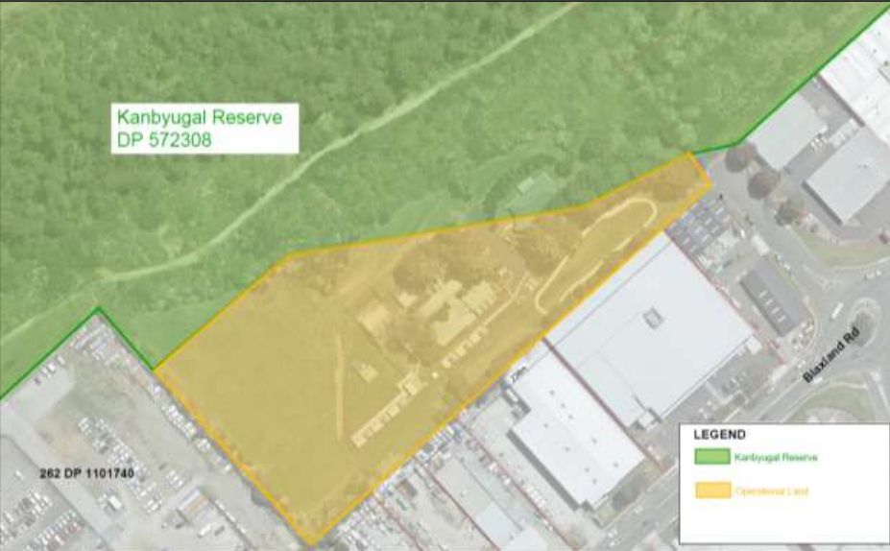Figure 1 Current land classification (source: planning proposal, February 2023)
Community land
Operational land

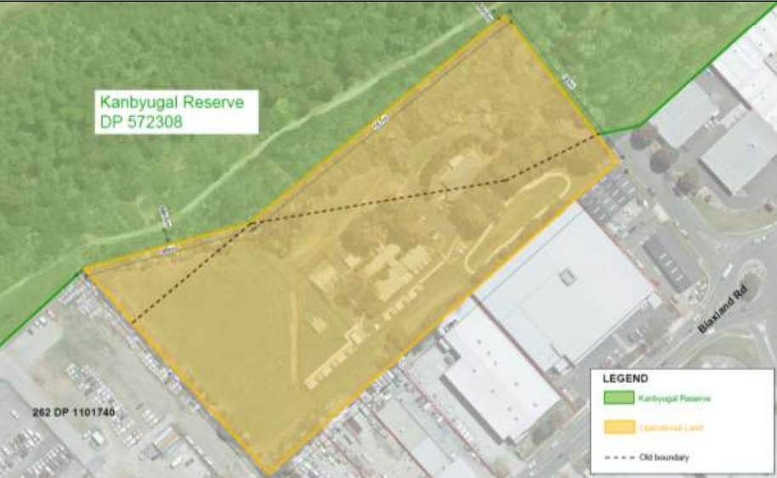Figure 2 Proposed land classification (source: planning proposal, February 2023)
Community land
Operational land

Site description and surrounding area
The site is located at 2 Rose Street, Campbelltown and is legally described as Lots 21 and 22 of DP 572308. It is an irregular shape and the two lots have a combined area of approximately 110,100sqm. However, the planning proposal seeks to amend the zoning and land classification for only part of Lot 22 DP 572308. (See Figures 2 and 3)
The site is owned by Council. It is occupied by an animal care facility and forms part of the Kanbyugal Reserve. The part of the site containing the animal care facility is predominantly cleared and developed, while the portion of the site used for the reserve is heavily vegetated and bushfire prone. The animal care facility is built over the lot boundary.
The site is located near the centre of Campbelltown, between the Hume Highway (M31) and Campbelltown Train Station. It is adjacent to low density residential development to the north, Kanbyugal Reserve to the north-east, and retail and light industrial uses to the east, south, and south-west. (See Figure 4)
2 Rose Street is currently zoned part IN2 Light Industrial and is classified as operational land. Kanbyugal Reserve is currently zoned RE1 Public Recreation and is classified as community land. (See Figures 1 and 5)
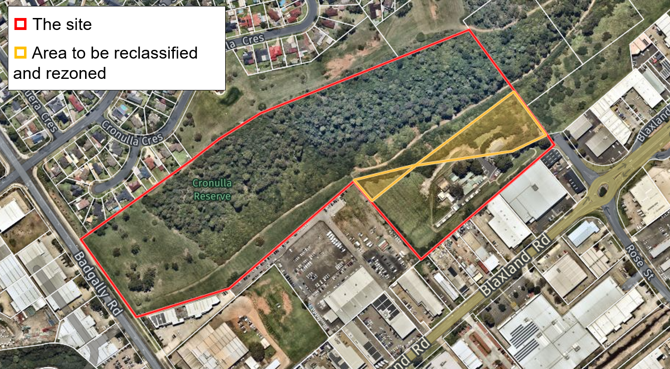Figure 3 Subject site (source: Nearmap, March 2023)

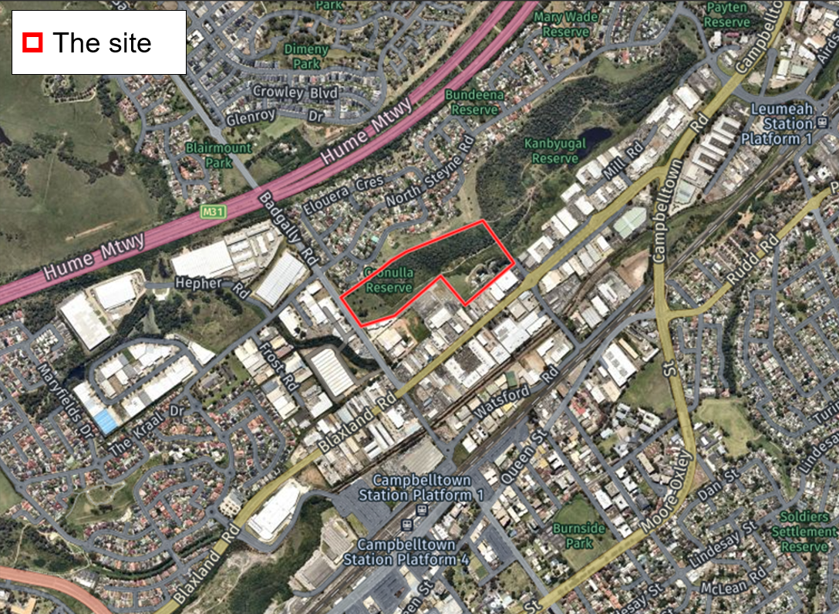Figure 4 Site context (site identified in red outline) (source: Nearmap, March 2023)

Mapping
The planning proposal includes mapping showing the proposed changes to the Land Zoning, Height of Buildings, Lot Size and Land Reclassification (Part Lots) maps.
To help ensure the community can clearly identify the proposed map changes during exhibition, the maps within the planning proposal should be updated. The maps in the planning proposal document should be at a legible scale and clearly identify the part of the lot that the changes apply to. A Gateway condition has been included to this effect.
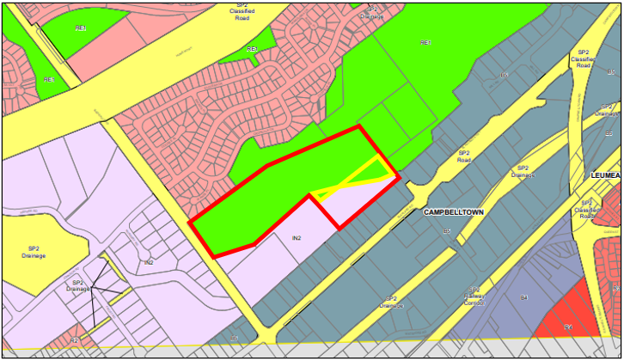
Figure 5 Current zoning map (source: Campbelltown LEP 2015) (subject part lots outlined in yellow)
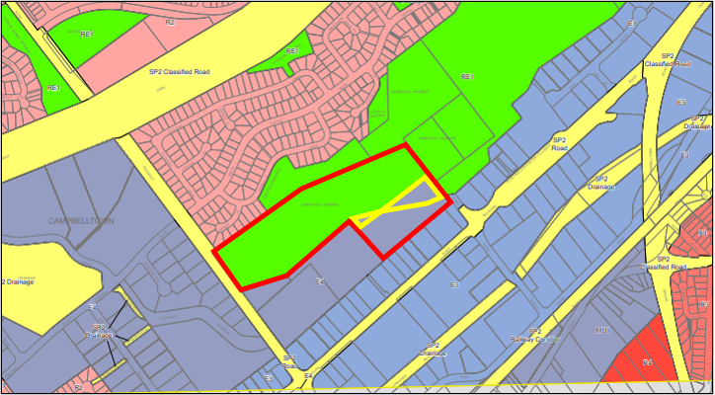
Figure 6 Proposed zoning map (source: planning proposal, February 2023) (subject part lots outlined in yellow)

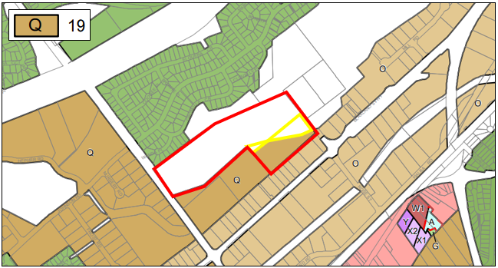Figure 7 Current Height of Buildings map (source: Campbelltown LEP 2015) (subject part lots outlined in yellow)
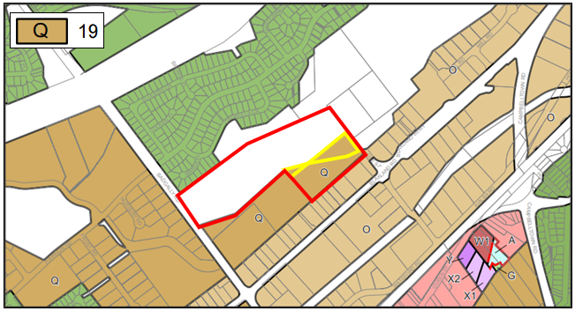
Figure 8 Proposed Height of Buildings map (source: planning proposal, February 2023) (subject part lots outlined in yellow)
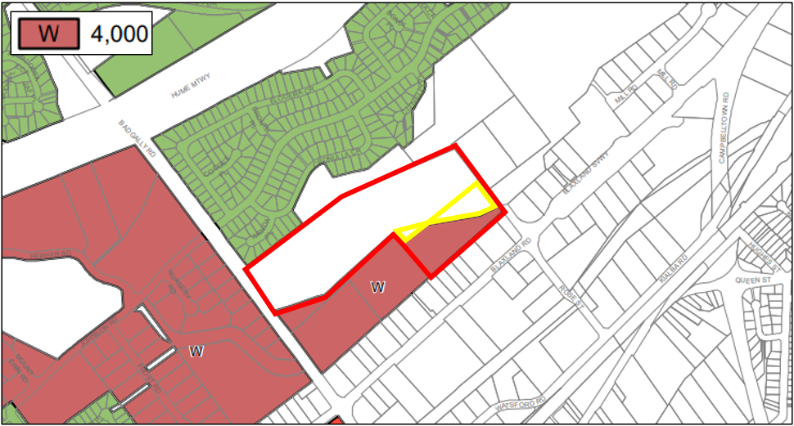
Figure 9 Current Lot Size map (source: Campbelltown LEP 2015) (subject part lots outlined in yellow)
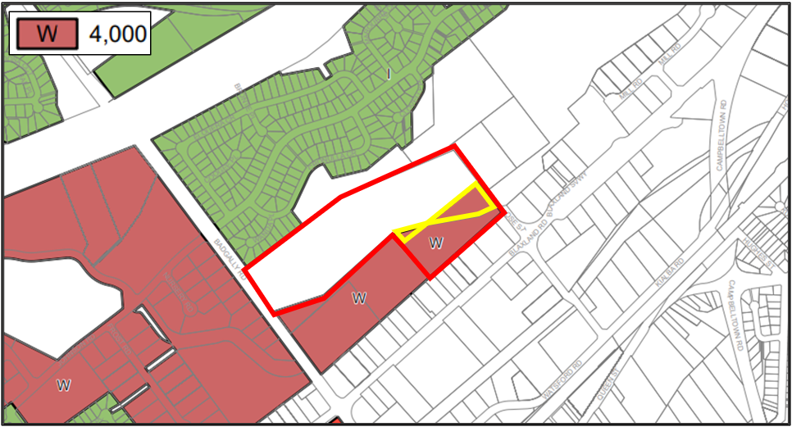
Figure 10 Proposed Lot Size map (source: planning proposal, February 2023) (subject part lots outlined in yellow)
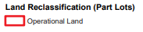
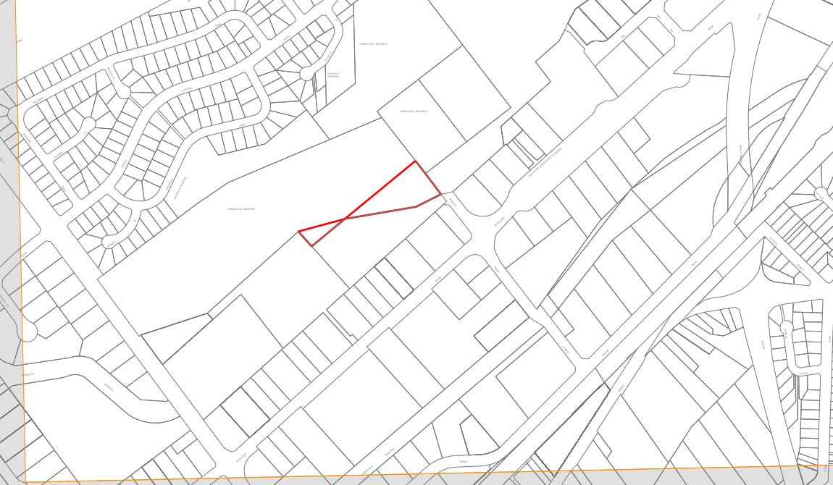
Figure 11 Proposed Land Reclassification (Part Lots) map (source: planning proposal, February 2023)

Need for the planning proposal
The planning proposal is not the result of a local strategic planning statement, or Department approved strategy or report. The need to realign the land classification and development controls to reflect the current land use as an Animal Care Facility was identified as a housekeeping matter during Council’s LEP Review 2019/2020.
Under section 25 of the Local Government Act 1993, public land in the management of council must be classified either ‘community’ or ‘operational’. Community land is generally for public access and use and is subject to requirements for its management. Operational land is not subject to the same restrictions and is generally used by Council to carry out its functions and/or generate income.
The proposal seeks to reclassify part of the subject site from ‘community’ to ‘operational’ land. Under section 27 of the Local Government Act 1993, reclassification of public land from ‘community’ to ‘operational’ is by way of a local environmental plan (subject to conditions).
The proposal also seeks to update the land use zone and development standards on the site to match the adjoining operational land and to reflect the current land use. A planning proposal is the most appropriate mechanism to make these updates.
A planning proposal to amend the LEP is the appropriate mechanism for reclassifying land from ‘community’ to ‘operational’ and apply the proposed zoning and development standards.

Strategic assessment

Regional and District plans

Greater Sydney Region Plan
The Campbelltown local government area (LGA) is subject to the Greater Sydney Region Plan: A Metropolis of Three Cities (March 2018). The planning proposal is consistent with the relevant objectives of the Region Plan, as outlined in Table 5 below.
Table 5 Regional Plan assessment
Regional Plan Objectives | Justification
Objective 3: Infrastructure adapts to meet future needs | Objective 3 seeks to ensure Greater Sydney’s supporting infrastructure can adapt and transition alongside technological changes and trends.  The planning proposal seeks to amend the land zoning and public land classifying to reflect the current use of the land for Council’s Animal Care Facility.  The is considered consistent with this objective as it will help facilitate the ongoing use of the land for a Council facility that addresses demand relating to animal care.
Objective 23: Industrial and urban services land is planned, retained and managed | Objective 23 seeks to recognise the value and function of industrial and urban services land within Greater Sydney, and to plan for, retain, and manage such land.  The planning proposal seeks to amend the land zoning and public land classifying to reflect the current use of the land for Council’s Animal Care Facility. The planning proposal will also result in a modest increase in industrial and urban services land.
Objective 31: Public open space is accessible, protected and enhanced | Objective 31 seeks to recognise the value of public open space within Greater Sydney, and to protect and manage open spaces.  Whilst the planning proposal seeks to rezone recreation land to industrial, the proposed reclassification and rezoning reflects existing land uses and does not materially reduce available public open space.
Objective 37: Exposure to natural and urban hazards is reduced | Objective 37 seeks to reduce exposure to natural and urban hazards and build resilience to shocks and stresses through effective land use planning and design.  The planning proposal is not inconsistent with this objective because the proposed reclassification and rezoning reflects existing land uses and is not expected to materially increase exposure to hazards.  Flood hazards are discussed further in section 4.1 of this report.

Western City District Plan
The Campbelltown LGA is subject to the Western City District Plan (March 2018). The planning proposal is consistent with the relevant planning priorities, as outlined in Table 6 below.
Table 6 District Plan assessment
District Plan Priorities | Justification
Planning Priority W1: Planning for a city supported by infrastructure | Planning Priority W1 seeks to ensure new infrastructure at local, district or metropolitan levels is planned and delivered to meet the needs of Greater Sydney.  The planning proposal makes administrative changes in relation to the management of land occupied by Council’s Animal Care Facility and will allow Council to improve and adapt the facility in future as required.
Planning Priority W18: Delivering high quality open space | Planning Priority W18 seeks to optimise open space areas and establish physical links that support social networks and a sense of community.  Whilst the planning proposal seeks to rezone recreation land to industrial, the proposed reclassification and rezoning reflects existing land uses and does not materially reduce available public open space.
Planning Priority W20: Adapting to the impacts of urban and natural hazards and climate change | Planning Priority W20 seeks to reduce exposure to natural and urban hazards and build resilience to shocks and stresses.  The planning proposal is not inconsistent with this objective because the proposed reclassification and rezoning reflects existing land uses and is not expected to materially increase exposure to hazards.  Flood hazards are discussed further in section 4.1 of this report.

Glenfield to Macarthur Urban Renewal Corridor Strategy and Campbelltown Precinct Plan
The subject site is subject to the Glenfield to Macarthur Urban Renewal Corridor Strategy (July 2015) and the Campbelltown Precinct Plan (2017). The Strategy and seeks to transform and revitalise the communities around the seven train stations between Glenfield and Macarthur, forming a highly connected and accessible corridor where residents can work, live and play.
The vision for Campbelltown-Macarthur is a Regional City Centre offering higher order civic, cultural, employment, residential and retail opportunities. The structure plan for the Campbelltown precinct recognises the industry & innovation function of the subject land.
The planning proposal seeks to formalise and future proof an existing council facility. This facility serves several purposes, including housing surrendered and impounded animals, and promoting de-sexing, microchipping and registration of animals. Council notes that the Campbelltown Animal Care Facility remains an important piece of community infrastructure for the surrounding area.
The structure plan maps show the site is an area identified for continued industrial and public recreation use. The planning proposal is considered consistent with the Strategy and Plan.

Local plans
The proposal states that it is consistent with the relevant local plans and endorsed strategies, as outlined in Table 7 below:

Table 7 Local strategic planning assessment
Local Strategies | Justification
Local Strategic Planning Statement | The LSPS is Council’s plan to meet the Campbelltown community’s social, environmental and economic land use needs over the next 20 years. It provides context and direction for land use decision making within the Campbelltown LGA.  Council states that the planning proposal is not inconsistent with the outcomes listed.  The planning proposal seeks to support the ongoing operation of the Campbelltown Animal Care Facility which is an important community facility. The planning proposal states is considered broadly consistent with the relevant outcomes of the Local Strategic Planning Statement.
Campbelltown Community Strategic Plan – Campbelltown 2027 | The community strategic plan guides Council’s policy initiatives and actions. It sets out outcomes to support a vibrant, liveable city, a respected and protected natural environment, a thriving attractive city, and a successful city.  The planning proposal is consistent with this plan as it will retain an existing service within the Campbelltown LGA.
Reimagining Campbelltown City Centre Master Plan | The planning proposal states that it is not inconsistent with the relevant outcomes of the Master Plan. It states that the amendment will promote opportunities for complimentary land uses on this and adjoining sites and will allow the Animal Care Facility to operate solely within operationally classified land.

Local planning panel (LPP) recommendation
The Campbelltown Local Planning Panel (LPP) considered the planning proposal on 28 September 2022. The LPP advised Council that it considered that the planning proposal had sufficient strategic and site specific merit to proceed to Gateway.
The LPP’s advice is summarised in Council’s report (Attachment H). It is recommended that the LPP advice be included in the planning proposal package exhibited on the ePlanning Portal. A Gateway condition has been included to this effect.

Section 9.1 Ministerial Directions
The planning proposal’s consistency with relevant section 9.1 Directions is discussed below:
Table 8 9.1 Ministerial Direction assessment
Directions | Consistent/ Not Applicable | Reasons for Consistency or Inconsistency
Direction 1.3  Approval and Referral Requirements | Consistent | The objective of Direction 1.3 is to ensure that LEP provisions encourage the efficient and appropriate assessment of development.  The planning proposal does not propose to introduce provisions into the LEP to require the concurrence, consultation or referral of DAs to a public authority.
Direction 1.4  Site Specific Provisions | Consistent | The objective of Direction 1.4 is to discourage unnecessarily restrictive stie specific planning controls.  The planning proposal does not seek to introduce site specific provisions into the LEP.
Direction 1.9  Implementation of the Glenfield to Macarthur Urban Renewal Corridor | Consistent | This Direction applies to the subject land. It seeks to ensure development within the precincts between Glenfield and Macarthur is consistent with the plans for these precincts.  The planning proposal is not inconsistent with the Glenfield to Macarthur Priority Urban Renewal Corridor Land Use and Infrastructure Strategy (July 2015). See also section 3.1.3 of this report.
Direction 1.14  Implementation of Greater Macarthur 2040 | Consistent | This Direction applies to the subject land. It seeks to ensure that development within the Greater Macarthur Growth Area is consistent with Greater Macarthur 2040 (November 2018), the Greater Macarthur Growth Area Structure Plan 2022, and the Guide to the Greater Macarthur Growth Area (November 2022). The 2022 Structure Plan for Land Release Areas of Growth Area identifies the site as ‘excluded area’.  The planning proposal seeks to support the ongoing operation of an important community facility.  The planning proposal is not inconsistent with the relevant plans for the Greater Macarthur Growth Area.
Direction 3.2  Heritage Conservation | Consistent | The objective of Direction 3.2 is to conserve items, areas, objects and places of environmental heritage significance and indigenous heritage significance.  The subject site is not identified as a heritage item and does not seek to reduce the provisions relating to heritage conservation in the LEP.  The planning proposal relates to an existing use of the land and is unlikely to have result in impact on environmental heritage. Heritage provisions will continue to apply to any future development on the land.
Direction 3.7  Public Bushland | Inconsistent | The objective of Direction 3.7 is to protect bushland in urban areas, including rehabilitated areas, and ensure the ecological viability of the bushland.  The planning proposal relates to an existing land use and does not seek to materially reduce existing public bushland. As the proposal includes rezoning of the land a condition has been included on the Gateway determination to address Direction 3.7 for completeness.
Direction 3.10  Water Catchment Protection | Inconsistent | The objectives of Direction 3.10 are to maintain, protect, improve and enhance natural waterbodies, water processes, and ecological connectivity.  The majority of the Campbelltown LGA is within the Georges River catchment, which is a regulated catchment.  The Direction requires planning proposal authorities to be satisfied that the planning proposal is consistent with the terms of the Direction. For completeness, a condition has been included on the Gateway determination to address Direction 3.10.
Direction 4.1  Flooding | Inconsistent | The objectives of Direction 4.1 are to implement the NSW Government’s Flood Prone Land Policy and the principles of the Floodplain Development Manual 2005 and ensure that provisions of an LEP that apply to flood prone land are commensurate with flood behaviour and includes consideration of the potential flood impacts both on and off the subject land.  This direction applies when a relevant planning authority prepares a planning proposal that creates, removes or alters a zone or a provision that affects flood prone land.  The subject site was identified as affected by 20% Annual Exceedance Probability (AEP) floods in Council’s Bow Bowing Bunbury Curran Creek Catchment Strategic Floodplain Risk Management Study and Plan (2019). See discussion at section 4.1 below.  The planning proposal seeks to support the ongoing operation of an existing community facility by rezoning and reclassifying the land. It does not seek to permit centre-based childcare facilities, hostels, boarding houses, group homes, hospitals, residential care facilities, respite day care centres and seniors housing in areas where the occupants of the development cannot effectively evacuate.  The proposal is not likely to result in a substantially increased requirement for government spending on flood mitigation.  A condition has been included on the Gateway determination to update the planning proposal to address Direction 4.1.
Direction 4.3  Planning for Bushfire Protection | Inconsistent | The objectives of Direction 4.3 are to protect life, property and the environment from bush fire hazards by discouraging incompatible land uses and to encourage sound management of bushfire prone areas.  The planning proposal applies to land that has been mapped as bushfire prone (see Figure 12 below).  Direction 4.3 requires consultation with NSW Rural Fire Service for planning proposals affecting bushfire prone land. The Gateway determination includes a condition to this effect.  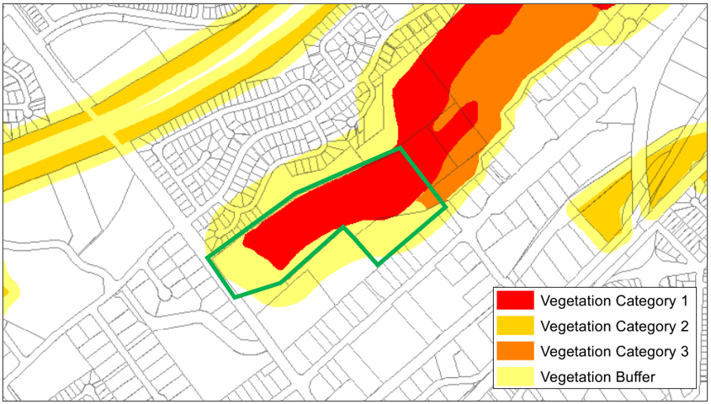 Figure 12 Excerpt of Council’s Bushfire Prone Land map (30 December 2020) (subject site identified by green outline) (source: Campbelltown City Council, March 2023)
Direction 4.4  Remediation of Contaminated Land | Consistent | The objective of Direction 4.4 is to reduce the risk of harm to human health and the environment by ensuring that contamination and remediation are considered by planning proposal authorities.  Direction 4.4 requires planning proposal authorities consider and plan for land contamination risk.  The planning proposal states that the existing land use is unlikely to result in land contamination or hazardous types of development and that future development on the site will be subject to the requirements of the SEPP (Resilience and Hazards) 2021. The planning proposal does not seek to permit residential, childcare or a hospital.  The planning proposal is consistent with Direction 4.4
Direction 5.2  Reserving Land for Public Purposes | Justifiably inconsistent | The objective of Direction 5.2 is to facilitate the reservation of land for public purposes and the removal of such reservations where they are no longer required.  The planning proposal seeks to reclassify and rezone the land to reflect the existing use of the site for use as an animal care facility by Council. The inconsistency with this Direction is considered justified.
Direction 7.1  Business and Industrial Zones | Consistent | The objectives of Direction 7.1 are to encourage employment growth in suitable locations, protect employment land in business and industrial zones and support the viability of identified centres.  Direction 7.1 requires planning proposals to give effect to the objectives of the direction, to retain employment land, to not reduce employment floorspace and to ensure that proposed employment areas are consistent with applicable strategies.  The planning proposal relates to an existing land use which is located on land zoned part RE1 Public Recreation and Part IN2 Light Industrial. It seeks to apply a consistent land classification and zoning to the subject part of the site which will result in a modest increase to employment zoned land.

State environmental planning policies (SEPPs)
The planning proposal is consistent with all relevant SEPPs as discussed in Table 9 below.
Table 9 Assessment of planning proposal against relevant SEPPs
SEPPs | Requirement | Consistent/ Not Applicable | Reasons for Consistency or Inconsistency
SEPP (Biodiversity and Conservation) 2021 | Chapter 4 – Koala habitat protection 2021  Chapter 6 – Water catchments  Chapter 13 – Strategic conservation planning | Consistent | Chapter 4 aims to encourage the conservation and management of areas of natural vegetation that provide habitat for koalas to support a permanent free-living population over their present range and reverse the current trend of koala population decline.  The subject site is subject to the Campbelltown Comprehensive Koala Plan of Management 2018. Chapter 4 of the SEPP requires that development applications must be consistent with the koala plan of management.  Chapter 6 applies to development in the Sydney Drinking Water Catchment, Sydney Harbour Catchment, the Georges River Catchment, and the Hawkesbury-Nepean Catchment.  The planning proposal applies to land in the Georges River Catchment. Chapter 6 of the SEPP requires consent authorities to consider impacts on water quality and quantity, aquatic ecology, flooding, recreation and public access, and downstream impacts before granting development consent.  Chapter 13 aims to ensure development in the nominated areas is consistent with the biodiversity certification, to facilitate appropriate development on biodiversity certified areas, to identify and protect areas with high biodiversity value, to avoid or minimise impacts from future development on biodiversity values, and to support the acquisition of priority areas with high biodiversity value.  The planning proposal applies to land identified on the Strategic Conservation Planning Land Application Map but is not identified as a Strategic Conservation Area. The land is identified on the Cumberland Plain Conservation Plan Viewer as ‘Excluded land’.  The planning proposal is not inconsistent with the relevant chapters of the SEPP.
SEPP (Resilience and Hazards) 2021 | Chapter 3 – Hazardous and offensive development  Chapter 4 – Remediation of land | Consistent | Chapter 3 aims to amend the definitions and development consent matters relating to hazardous and offensive industries.  The existing and intended uses of the land are unlikely to result in hazardous or offensive land uses.  Chapter 4 aims to provide for a Statewide planning approach to the remediation of contaminated land.  The planning proposal does not interfere with the operation of the chapter. Future development on the site will need to address the requirements of the chapter.  The planning proposal is not inconsistent with the relevant chapters of the SEPP.
SEPP (Transport and Infrastructure) 2021 | Chapter 2 – Infrastructure | Consistent | Chapter 2 aims to facilitate the effective delivery of infrastructure across the State.  The proposal seeks to support the operation of an existing facility. Any future development on the site that may constitute traffic generating development and may require referral to TfNSW at the development stage.  The planning proposal does not affect the operation of the SEPP.

Site-specific assessment

Environmental

Flooding
The 2022 Flood Inquiry recommends taking a risk based approach to flooding.
The subject land is identified as affected by the 20% AEP flood level in Council’s Bow Bowing Bunbury Curran Creek Catchment Strategic Floodplain Risk Management Study and Plan (2019) (see Figure 13 below). For clarity, it is recommended a summary of the Bow Bowing Bunbury Curran Creek Catchment Flood Management Study to identify the flooding risk, behaviour, vulnerability (H1-H6 classification) and impact/risk to life associated with development types permissible in the proposed zone.
The planning proposal seeks to support the ongoing operation of an existing community facility by rezoning and reclassifying the land. It does not seek to permit centre-based childcare facilities, hostels, boarding houses, group homes, hospitals, residential care facilities, respite day care centres and seniors housing in areas where the occupants of the development cannot effectively evacuate. The proposal is not likely to result in a substantially increased requirement for government spending on flood mitigation.
However, whilst the proposal seeks to support the ongoing operation of an existing community facility, the planning proposal does include rezoning the land to E4 General Industrial. As discussed above, the planning proposal is updated prior to exhibition address Ministerial Direction 4.1 Flooding.
Gateway conditions have been included to this effect.
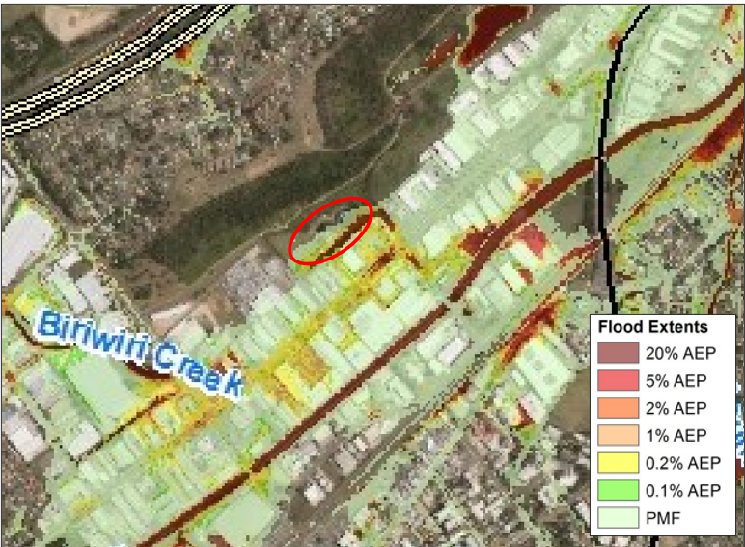
Figure 13 Excerpt of the ‘Flood Extends with Hazard ≥ 2’ map in Bow Bowing Bunbury Curran Creek Catchment Strategic Floodplain Risk Management Study and Plan (adopted 5 February 2019) (approximate location of subject site identified by red outline) (source: Campbelltown City Council)

Social and economic
The planning proposal will result in a modest reduction to RE1 Public Recreation zoned land. This loss is considered minor and justified because the subject land is already in use as an animal care facility and the planning proposal seeks to recognise this existing use.
The planning proposal describes the animal care facility as an important asset to Council and to the wider Sydney community and Council has not indicated any intention to sell the site.
It is unlikely that the proposed amendment will have any adverse social or economic impacts

Infrastructure
The site is currently serviced by infrastructure and utilities.

Consultation

Community
The planning proposal is classified as ‘standard’ in the Local Environmental Plan Making Guideline (September 2022). The benchmark community consultation timeframe in the Guideline for standard planning proposals is 20 working days.
It is noted that for planning proposals involving reclassification of public land, the LEP Practice Note PN 16-001 requires least 28 (calendar) days for public exhibition, and that the Local Government Act 1993 requires a public hearing to be held.
Accordingly, the Gateway determination includes a condition that the planning proposal be exhibited for a minimum of 20 working days. Council should consider the requirements of the Local Government Act 1993 and PN 16-001 when exhibiting the planning proposal.

Agencies
The proposal does not specifically raise which agencies will be consulted.
It is recommended the following agencies be consulted on the planning proposal and given 30 working days to comment:
- NSW Rural Fire Service
The Gateway determination includes a condition to this effect.

Timeframe
Council proposes a 7 month time frame to complete the LEP.
The planning proposal is classified as ‘standard’ in the Local Environmental Plan Making Guideline (September 2022). The benchmark timeframe in the Guideline for standard planning proposals is 200 working days from the issued Gateway determination to finalisation. This is approximately 10 months.
Accordingly, consistent with the LEP Making Guideline and allowing for a public hearing into the reclassification and the Christmas shut down period, the Department recommends an LEP completion timeframe of 10 months. The Gateway determination includes a condition to this effect.

Local plan-making authority
As the site is owned by Council and is seeking reclassification from ‘community’ to ‘operational’, the Department recommends that Council not be authorised to be the local plan-making authority for this proposal.

Assessment summary
The planning proposal is supported to proceed with conditions for the following reasons:
- The planning proposal is the most appropriate way to achieve the objectives and intended outcomes.
- The planning proposal has demonstrated potential strategic and site specific merit, subject to the recommended conditions and agency consultation.
Based on the assessment outlined in this report, the proposal must be updated before consultation to:
- Clarify the objectives and intended outcomes, including updating all rezoning references from IN2 Light Industrial to E4 General Industrial.
- Ensure clear maps and the Local Planning Panel advice are exhibited as part of the planning proposal.
- Address 9.1 Ministerial Directions, including Directions 3.7 Public Bushland, 3.10 Water Catchment Protection, and 4.1 Flooding.

Recommendation
It is recommended the delegate of the Secretary:
- Note that the consistency with section 9.1 Ministerial Directions 3.7 Public Bushland, 3.10 Water Catchment Protection, 4.1 Flooding, and 4.3 Planning for Bushfire Protection is unresolved until additional information is provided and relevant consultation is undertaken.
It is recommended the delegate of the Minister determine that the planning proposal should proceed subject to the following conditions:
- Prior to community consultation, the planning proposal is to be updated to:
  - Clarify that the planning proposal does not involve a subdivision or any other lot boundary adjustments and that the proposed rezoning and reclassification apply to part lots.
  - Explain how the Animal Care Facility is a permissible use under the incoming E4 General Industrial zone for clarity.
  - Update all references to the IN2 Light Industrial zone to refer to the incoming E4 General Industrial zone.
  - Clarify whether the land is subject to an considered an implied or informal public reserve and whether is seeking to extinguish this as part of the planning proposal
  - Clearly identify the subject site on all maps within the planning proposal and ensure maps in the planning proposal document are a legible scale.
  - Address Section 9.1 Ministerial Directions 3.7 Public Bushland, 3.10 Water Catchment Protection, and 4.1 Flooding.
  - Provide a copy of the Local Planning Panel advice as a supporting document.
- Public exhibition is required under section 3.34(2)(c) and clause 4 of Schedule 1 to the Act as follows:
- the planning proposal is categorised as standard as described in the Local Environmental Plan Making Guidelines (Department of Planning and Environment, 2021) and must be made publicly available for a minimum of 20 working days; and
- the planning proposal authority must comply with the notice requirements for public exhibition of planning proposals and the specifications for material that must be made publicly available along with planning proposals as identified in Local Environmental Plan Making Guidelines (Department of Planning and Environment, 2021).
- Consultation is required with the following public authorities and government agencies under section 3.34(2)(d) of the Act and/or to comply with the requirements of applicable directions of the Minister under section 9 of the EP&A Act:
- NSW Rural Fire Service

Each public authority is to be provided with a copy of the planning proposal and any relevant supporting material via the NSW Planning Portal and given at least 30 working days to comment on the proposal.
- A public hearing is not required to be held into the matter by any person or body under section 3.34(2)(e) of the EP&A Act. This does not discharge Council from any obligation it may otherwise have to conduct a public hearing.
- A public hearing is required to be held in accordance with Section 29 of the Local Government Act 1993 and the Department’s Practice Note PN 16-001.
- Given the nature of the proposal, Council is not authorised to be the local plan-making authority.
- The LEP should be completed on or before 5 March 2024.

_____________________________ ______28/04/2023___________
Kelly McKellar
Specialist Planning Officer, Agile Planning

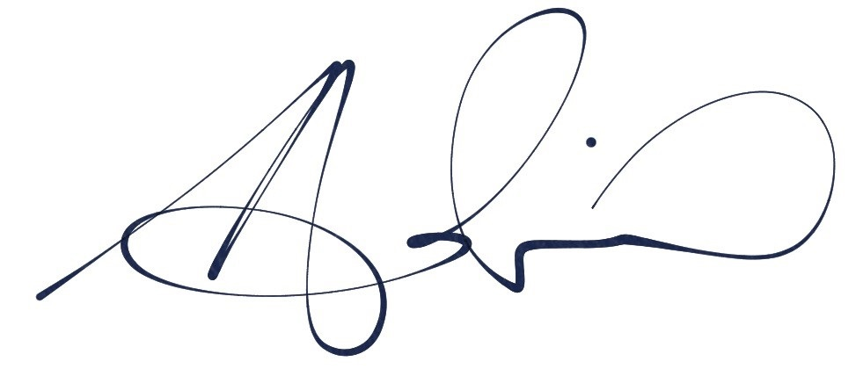 _____14 May 2023______
Adrian Hohenzollern
Director, Western District

Assessment officer
Rachel Hughes
Planning Officer, Agile Planning
(02) 9995 5936

